Motivation+ 3Cs in 3 Cases
Case1: Use Ice-Breakers to Improve Team Work
Case Description: In 2007, I got a chance to be an intern in an advertisement company. I was assigned to a new built team of two young staff and a middle aged manager. The manager was just promoted, so he did not have too much experience as a team leader. Our main job was contacting advertising directors of various media to request collaboration, but before that we had to go through the most painstaking process of looking for contact information of those directors.
Members in our team did not communicate too much. Most of the time we were bound up in individual business; every few days we held a small meeting reporting each one’s progress. Sometimes I felt cheerless and even lonely. I wanted to hear my team members’ suggestions and wanted to get encouragement from them, I also hoped we can fight side-by-side! But meanwhile I suspected the fact that we were a team: we did not know each other quite well. I bet the only thing they knew about me was “an intern from Beijing Normal University (maybe they had forgotten this name or had never remembered it)”, because our manager introduced me to them in this simple way when we first met. Besides, I found they did not know each other too much either. The manager was upset that one member in our team always hurried to check off (working overtime is common and encouraged in China). He didn’t know that woman was busy preparing her wedding!
Maybe team members can become acquainted as time goes by. But low efficiency in business world means losing chances and being defeated. One month later, we lagged behind other teams. When other teams had gathered abundant contacting information through various ways, we were still stick on internet and achieved little. I told my manager if I had known that we could use the contact manual of post office, I would have got one from one of my relative who was working there. “Why not tell me this earlier!” My manager complained. But when was I given time to say this?
Problem: Members in a new team were not provided enough chances to know each other, which led to less communication, lack of mutual understanding, low motivation and inefficiency of information exploration.
Solution: The manager organizes team members to paly following motivational ice-breaker activities at the very beginning of the building of the team: Self-disclosure Introductions, Expectation Charts, Treasure Hunts, Accomplishment Hunts, Coat of Arms, Psychic Massage, Community Building. (See Pic.1)
Further Explanation:
- The manager should choose one or several above activities based on factors like available time amount, members’ ages and personalities, mission of the team.
- Activities should focus on issues in job setting. Besides talking a little bit about personal life, most of disclosed information should be centered on job experience. For instance, talk about working accomplishments in Accomplishment Hunts. In this way, the less experienced member can learn from experienced ones and members could be able to find working resources form each other.
- Psychic Massage should be more appropriate to be used in situations where a few new members join in while most other team members are acquaintances. In this activity, new members get chance to know old members from positive perspectives.
- It should be allowed for everyone to keep certain personal information secret if they do not want to disclose them.
Case 2: Use Thinking Skills to Enhance Leadership
Case Description: After graduation from my university in China, I found a job as a children’s book editor in a culture company. This should be an amazing job, full of fun and creative ideas. However my beautiful dream was broken by my supervisor. He had many working experience in book distribution and selling, but knew little about editing, especially children’s book editing. He totally had no idea about colors and stories. Besides, we found he also lacked critical thinking ability. His mind was always as messy as his table, piled with all sorts of books and papers and other irrelative stuffs, which blocked him to make quick and right decisions.
Due to this horrible supervisor, our department—children’s book department—degraded from the most creative and productive department in people’s mind to the most unimaginative and inefficiency department in our company in reality. After working there for eight months, I left.
Problem: The supervisor’s lack of creativity and critical think abilities caused the bad performance of the whole department.
Solution: Now when I am looking back to my eight month nightmare in that department, I think my supervisor can do following things to enhance his leadership:
- Brain storm potential topics, stories, material and artistic styles with all editors before compiling new books.
- Use webbing to connect ideas and form several applicable plans.
- Conduct SWOT analysis to sift plans.
- If it is possible, do ROI analysis to assist decision-making.
(See Pic.2)
Further Explanation:
- Editors, no matter who are in charge of word editing or graphic design should all be invited in to brain storming and webbing sessions. When describing abstract ideas, visual thinking tools like flow charts and story maps are encouraged to use.
- When conducting SWOT and ROI analysis, other stakeholders and staff from other department (such as accountants) should attend the meeting and offer thoughts.
- If it is too hard to weigh two or several plans, use First Important Priority (FIP) to make final decision.
- It is advisable to let someone write down crucial decisions of the whole procedure as memo for future use.
Case 3: Use Fillips 66 Methods to Facilitate Learning of Computer Technology
Case Description: After applying my Master degree in IST department, I took a graphic design class in a computer technology training school in Beijing to gear myself with more technology skills. I stepped into the classroom with high expectation but soon realized that I had chosen a terrible class. The class was carelessly designed. It seemed that the trainer had never taken students’ learning abilities and experience into consideration.
His class was tedious. The lesson structure was never changed: in the first half of each class the trainer demonstrated how to use Photoshop or other graphic design soft wares to accomplish a design task, then in the second half of this class, we were asked us to accomplish this task by ourselves. When he demonstrated, we could not manipulate our computers because they were all set in the “simultaneously demonstrating” mode. We could just see what the trainer doing on the screen of our computers. I tried to write down each steps, but it was really hard to do so as well as to catch up the trainer’s rhythm. So when we got time to practice, I was always blocked by my poor memory, without ideas of how to do next. But it seemed that not only I was bothered by poor memory. Other students also met such trouble. Gradually I lost interests in this class because of my fruitless learning status.
Problem: The trainer’s rigid and ineffective train design extinguished learners’ learning desire. They felt disappointed since they devoted time and energy but without any achievement.
Solution: Fillips 66 method
In the second half of each class students are first given a few minutes to recall the steps in the previous demonstration. Then the trainer divides students into two groups. (Since we had 12 students, there were six students in each group.) Group members sit together to recall and practice the task. The trainer provides assistance to help each group completely finish the task. Then students sit back, sharing their practice experience in the whole class and discussing where difficulties are and which step should pay attention to. Finally students repeat practicing the whole design task in pairs. (See Pic.3)
Further Explanation:
- The number of team members and the minutes for group practice do not have to be six. The number of team members can be 1-2 more or less than six, while the amount of assigned time should be decided based on the difficulty of the given task.
- The trainer should try to ensure that groups are established with members from a range of levels of experience and backgrounds. Regroup students frequently based on the above rule to make sure that students get chance to communicate with different people.
- To make sure that all team members actively join in group activity, the trainer should assign each of them certain responsibilities. For example, ask two of them to take notes, the other two manipulate computers while the last two report learning experience in the whole class.
- As students become proficient enough in using certain soft wares, original design tasks (trainer doesn’t do any demonstration in advance) should be assigned. Each group can brain storm design ideas first then actualize them on computers. Carrying on competitions between groups might be a good idea, since it will make the class more engaging.

Appendices:
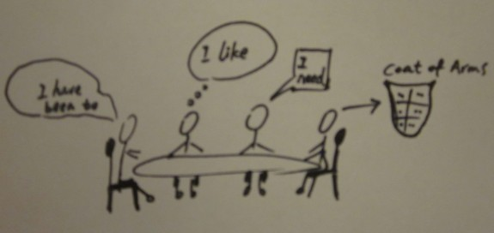 Pic.1
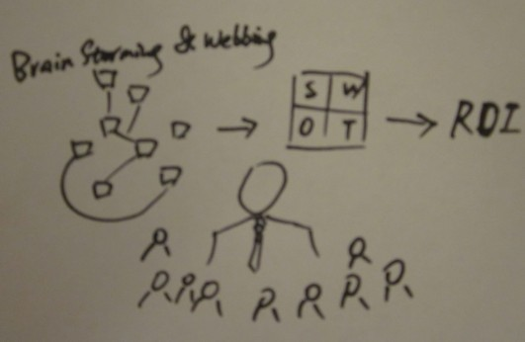 Pic.2
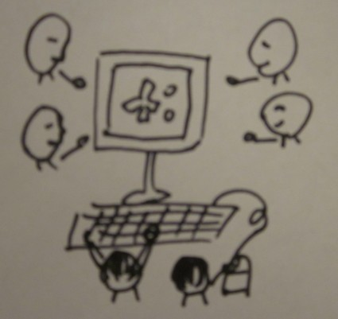 Pic.3

